ChEn 285 Lab Set Up
Viscometer
Equipment Needed:
- 2-4L glass beaker
- 2-Lachoi Hot plate w/ temperature probe
- 2-Stir bar
- 4-Viscometer
- 4-Ring stand
- 4-Three-prong clamp
- 4-Three-way bulb w/ tubing
You need two stations with all the equipment above and two stations with the last four items above (viscometer, ring stand, three-prong clamp, three-way bulb w/ tubing).

Other Equipment:
- Scale
- Small beakers

Chemicals Need:
- DI water
- Ethanol

To Set Up Station (start set up at least one hour before lab):
- Place two Lachoi hot plate w/ temperature probes on the table and plug into outlet.
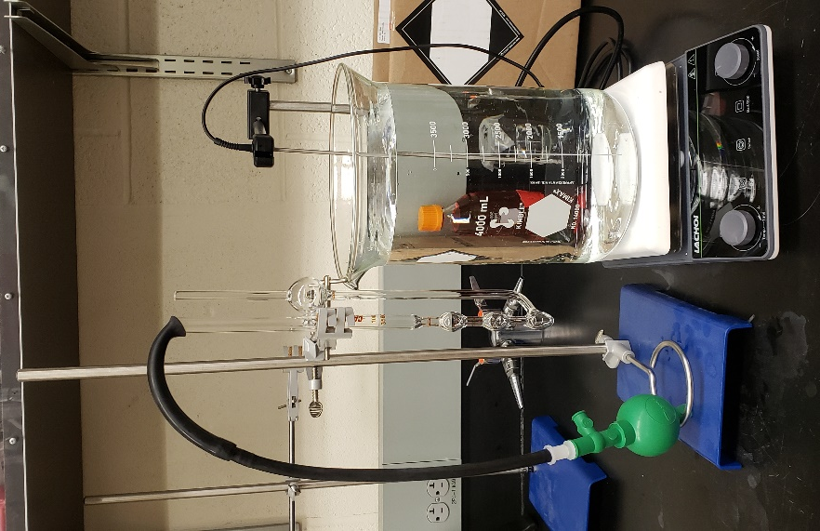
- Place one ring stand next to each hot plate with a three-prong clamp attached to each stand.
- Fill the two 4L glass beakers with water ½” from the top.
- Place the two 4L glass beakers onto the two hot plates.
- Drop the stir bar into each of the beakers.
- Turn the heater on and heat to 40°C while stirring with the stir bar at a minimum of 200 rpm.
- Place the empty viscometer in the clamp.
- Place the three-way bulb w/ tubing next to the set up.
- This portion is ready for the students.
- For the last two set ups, set up two rings stand viscometer stations without the water bath or hot plate.
- All stations are ready for the students.
- Fill and label a small beaker with ethanol (used to charge the viscometer and weigh for density).
- Fill and label another small beaker with DI water (used to charge the viscometer and weigh for density).
- Ensure a scale is available to be used to weigh the ethanol and DI water.

To Clean up Station:
- Turn off the hot plates and allow to cool to safe temperature.
- Once cooled, remove the stir bar and dump water into drain.
- Put the hot plate, stir bar, and 4L beaker away.
- Remove viscometers from clamps.
- Dump any remaining liquid from the viscometers in an appropriate waste container.
- Use ethanol to remove any remaining residue inside the viscometers.
- Blow air into the bulbs to dry using the three-way bulb w/ tubing
- Return viscometers and three-way-bulb w/ tubing to appropriate storing location.
- Return ring stand and three-prong clamp to appropriate storing location.

