Lab1: Viscosity

Group Number: Section Number:
Name
Other team members
(Circle the name of the person who acted as leader)

SAFETY SECTION:
This lab contains the use of water and ethanol with glass equipment. Ethanol is highly flammable. Keep away from open flames, sparks, heat sources, and electrical equipment that may cause ignition. Do not set out and leave open. Use caution when pouring or transferring ethanol. If water or ethanol is spilled, it must be cleaned up promptly.
The equipment is made of glass. Handle all equipment with care. Alert the instructor or TA if equipment is broken or if any cracks are found. Please alert the instructor or TA if you have a safety incident. As always, long pants, closed-toed shoes and safety glasses must be worn at all times.

Begin your lab by holding a team planning session (3 minutes):
- Review the lab and read the safety section if you haven’t already.
- One person should serve as leader/coordinator. All team members should strive to take make the team function better through various roles: observer, recorder, devil’s advocate, etc. Ask for each other’s input and opinions, help each other, and try to come to consensus after an appropriate amount of brainstorming and analysis.
- Make a plan for how you will complete the lab activities. Each person should fill out their own lab report as activities are completed. At the end of the hour, after cleaning up, get the TA to initial the end of your report.

Background: Viscosity measures a fluid's resistance to flow. It determines how easily a fluid moves: high viscosity means it flows slowly (like honey), while low viscosity means it flows quickly (like water). Factors like temperature and molecular structure affect viscosity. It's crucial in many fields of engineering—medicine, petroleum, and food—for designing machinery, creating products, and understanding fluid behavior.
Project: You will measure the viscosity of water and ethanol each at two varying temperatures and compare them to DIPPR.
Pre-Lab Preparation: Answer the following questions to prepare for the data collection and analysis.
- What is kinematic viscosity? What is dynamic viscosity? How do they relate? What is the formula that relates the two viscosities?

- What are the common units of kinematic and dynamic viscosities?

Lab: Familiarize yourself with the equipment and the instructions to properly use the equipment.
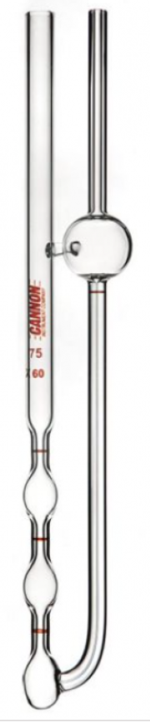
- Clean the viscometer using suitable solvent (ethanol).
- Connect the black hose to the tube arm L and connect the green three-way suction bulb to the quick connect on the black hose.
- Hold valve A and release the air inside the bulb.
- To charge the sample into the viscometer, invert the viscometer and apply suction to the tube arm L by holding the valve S and slowly allow the bulb to fill with air, immersing tube N in the liquid sample, and draw liquid to mark G. Turn the instrument to its normal vertical position.
- Place the viscometer into the holder and insert it into the constant temperature bath.
- Allow approximately 5 minutes for the sample to come to bath temperature.
- Ensure the meniscus is half-filled in bulb A. If the meniscus is greater than half-filled in bulb A, hold valve S and slowly press the bulb pushing the meniscus back towards bulb D.
- Be prepared to record time, then remove the three-way suction bulb from the quick connect and allow the liquid to travel upwards into bulb C. Measure the efflux time for the liquid to pass from mark E to mark F. Then, measure time from mark F to mark I.
- Calculate the kinematic viscosity of the sample by multiplying the efflux time in seconds by the viscometer constant for bulb C and J, respectively.
- Repeat measurement can be completed by putting the three-way suction bulb on the quick connect, push valve S and slowly squeezing the bulb until the meniscus level is half-filled in bulb A.
- Repeat steps 8-10 for measurements at constant temperature.
- Repeat steps 1-10 for measurements of a new substance.
- To clean up, clean the viscometer using suitable solvent (ethanol).

 | Constant mm²/s² (cSt/s)
Viscometer | Bulb C | Bulb J
359D | 0.01514 | 0.01102
358D | 0.01642 | 0.01256
960H | 0.09741 | 0.07055
971H | 0.09922 | 0.07340

Measurements:
- Measure the density of water and ethanol. Do NOT look it up online.

- Measure and calculate the kinematic viscosity of water and ethanol at 40°C and 25°C.

- Calculate the dynamic viscosity of water and ethanol at 40°C and 25°C.

- Compare your results to DIPPR. How do they compare? Explain what may have caused your values to be off or explain what you did to achieve values close to literature. How can you avoid any errors in the future?

- Which has a higher viscosity, water or ethanol? Why? Explain on the molecular level.

Grading Rubric (to be completed by TAs)

Points | Max
Completed Activities and write-up | 6
Accurate calculations and reasonable estimates | 3
Safety and cleanup: TA initial: | 1
Total | 10

